Project Development Phase

Dashboard & Story Screenshots
Project Title | India's Agricultural Crop Production Analysis
Domain | Agriculture / Data Analytics & Business Intelligence
Tool | Tableau Desktop / Tableau Public
Dataset | Historical Indian Crop Production Data, 1997–2021
Prepared By | Divya Kauluri (Team Project — completed individually; the team lead and other assigned members did not contribute to the work)
Mentor | N/A — Individual Submission
GitHub Repository | https://github.com/divyakauluri-spec/India-s-agricultural-crop-production-analysis
Tableau Public Link | https://public.tableau.com/app/profile/divya.kauluri/viz/IndiaAgricultureanalysisproject/IndiasAgricultureJourney?publish=yes
Date | 20/07/2026

Project Context
This report presents a comprehensive visual exploration of India’s agricultural cultivation using 25 years (1997–2021) of historical crop production data. Nine Tableau visualizations — a KPI Summary panel, State-wise Production Map, Year-wise Total Production chart, Trend of Agricultural Yield chart, Cultivated Area by Crop chart, State-wise Cultivated Area Comparison chart, Leading States by Production chart, Production Distribution by Unit Type donut, and Season-wise Production pie — are combined into four role-specific dashboards and a five-point guided Story, enabling stakeholders to uncover patterns, identify areas of growth or concern, and make data-driven decisions.
By harnessing the power of Tableau, this report presents the data in a visually appealing, interactive form that lets readers explore the intricacies of India’s agricultural cultivation for themselves.

Scenario 1: Small-Scale Farmer
Rajesh is a small-scale farmer in Uttar Pradesh who wants to maximize his crop yield and income. However, he struggles to decide which crops to grow each season due to changing weather patterns and market demand. By analyzing historical agricultural data (1997–2021), Rajesh needs insights into seasonal crop trends, regional productivity, and high-performing crops to make better farming decisions and reduce risk. The Farmer’s View dashboard serves Rajesh through the Cultivated Area by Crop and Season-wise Production charts.

Scenario 2: Government Policy Analyst
Ananya works with the Ministry of Agriculture and is responsible for designing policies to improve agricultural productivity across India. She needs to identify regions with low crop yield, understand long-term production trends, and evaluate the impact of seasonal variations. Using Tableau dashboards, she aims to uncover patterns in the data to support data-driven policy decisions and allocate resources effectively. The Policy Analyst’s View dashboard serves Ananya through the State-wise Production Map and Trend of Agricultural Yield chart.

Scenario 3: Agribusiness Investor
Vikram is an agribusiness investor looking to invest in high-growth agricultural sectors. He needs to analyze historical crop production data to identify profitable crops, emerging trends, and regions with consistent growth. By leveraging visual analytics in Tableau, Vikram seeks to minimize investment risk and make informed decisions on where and what to invest in the agricultural market. The Investor’s View dashboard serves Vikram through the Leading States by Production and Cultivated Area by Crop charts.

1. Dashboards
All four dashboards below are live on Tableau Public:
https://public.tableau.com/app/profile/divya.kauluri/viz/IndiaAgricultureanalysisproject/IndiasAgricultureJourney?publish=yes

Dashboard 1 — India Agricultural Performance Dashboard (Overview)
Combines all nine worksheets — KPI summary, State-wise Production Map, Trend of Agricultural Yield, Leading States by Production, Season-wise Production, Cultivated Area by Crop, State-wise Cultivated Area Comparison, Year-wise Total Production, and Production Distribution by Unit Type — into a single landing dashboard.

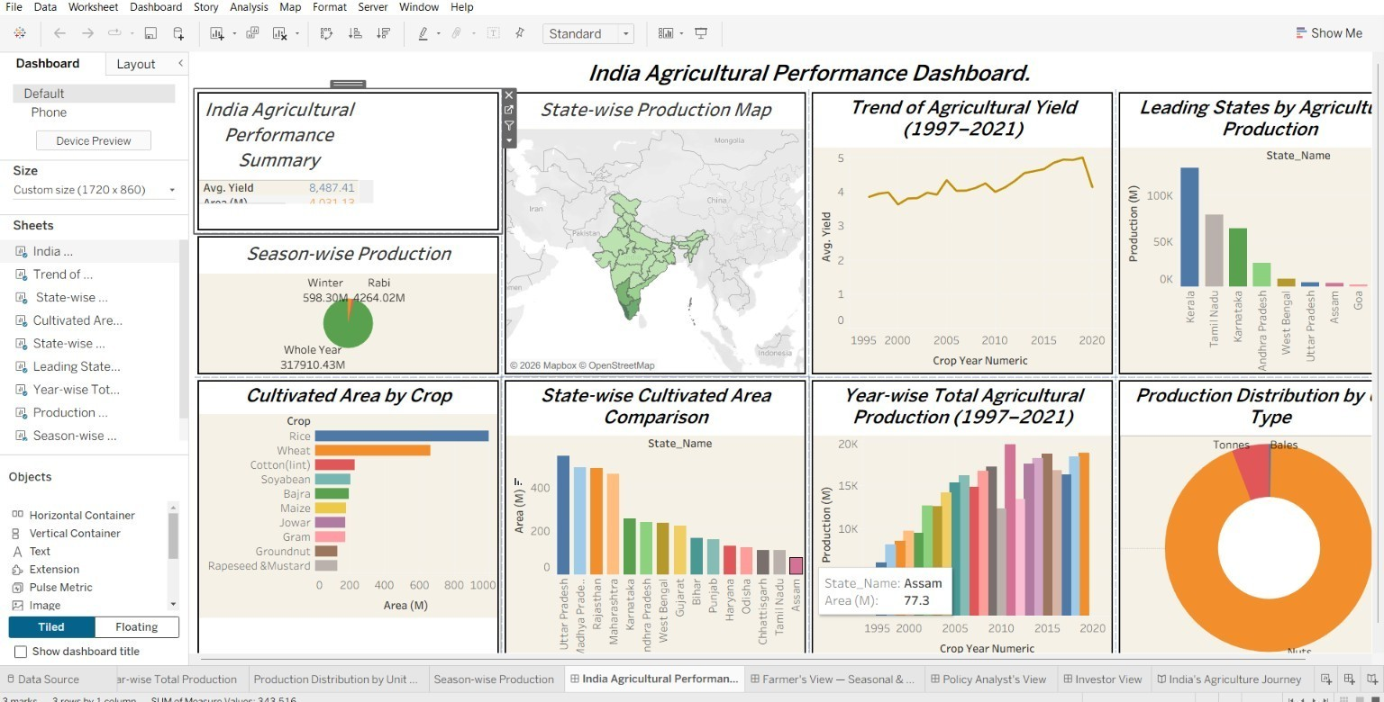
Dashboard 1 — India Agricultural Performance Dashboard (Overview)

Dashboard 2 — Farmer's View — Seasonal & Crop Insights
Combines Season-wise Production, Trend of Agricultural Yield, and Cultivated Area by Crop for season- and crop-level planning decisions.

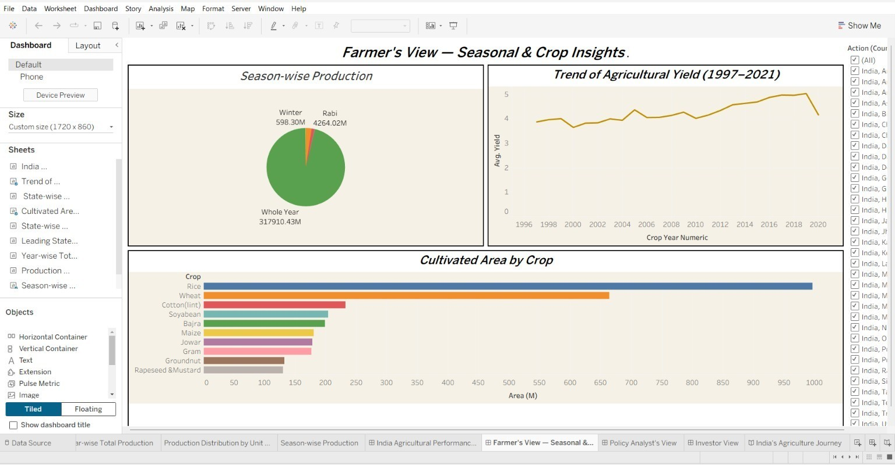
Dashboard 2 — Farmer's View — Seasonal & Crop Insights

Dashboard 3 — Policy Analyst's View — Regional Performance & Trends
Combines the State-wise Production Map, State-wise Cultivated Area Comparison, Trend of Agricultural Yield, and Leading States by Production for regional policy analysis.

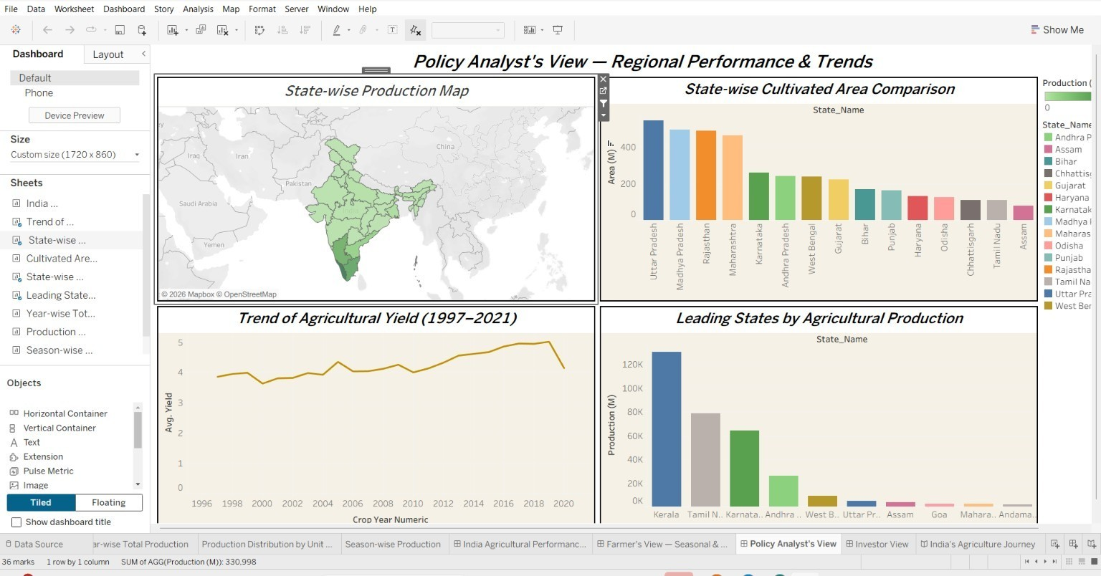
Dashboard 3 — Policy Analyst's View — Regional Performance & Trends

Dashboard 4 — Investor’s View — Growth & Opportunity Insights
Combines Year-wise Total Production, Leading States by Production, Cultivated Area by Crop, and Production Distribution by Unit Type for investment opportunity screening.

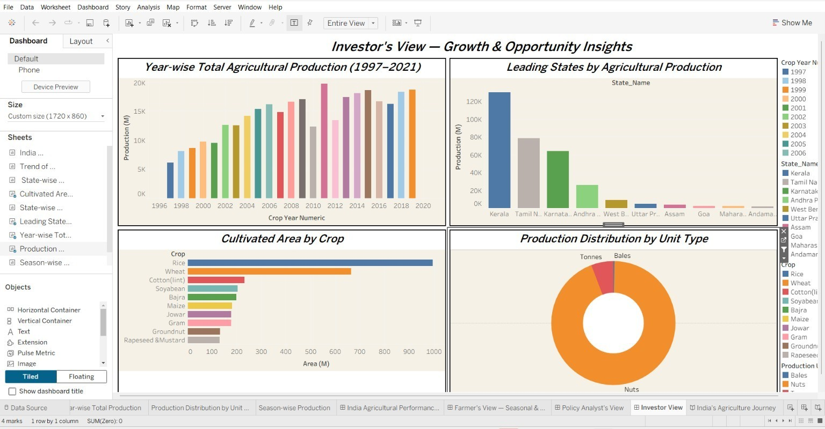
Dashboard 4 — Investor’s View — Growth & Opportunity Insights

2. Tableau Story — India’s Agricultural Journey: Insights from 25 Years of Data (1997–2021)
The full guided Story is available at the same public link listed above.

Story Point 1 — Overview
Opens with the full India Agricultural Performance Dashboard, framing the 25 years of data covered by the analysis.

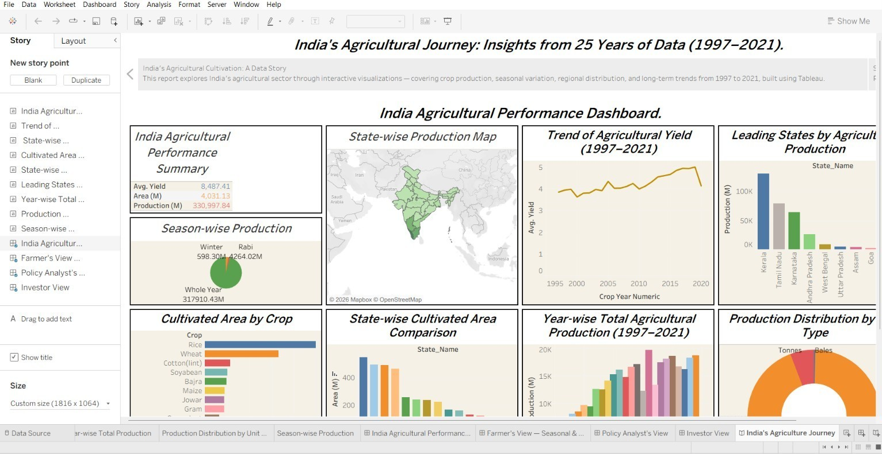
Story Point 1 — Overview

Story Point 2 — Scenario 1: The Small-Scale Farmer
Rajesh, a small-scale farmer in Uttar Pradesh, wants to maximise yield and income. The Farmer's View dashboard gives him seasonal and crop-level insights.

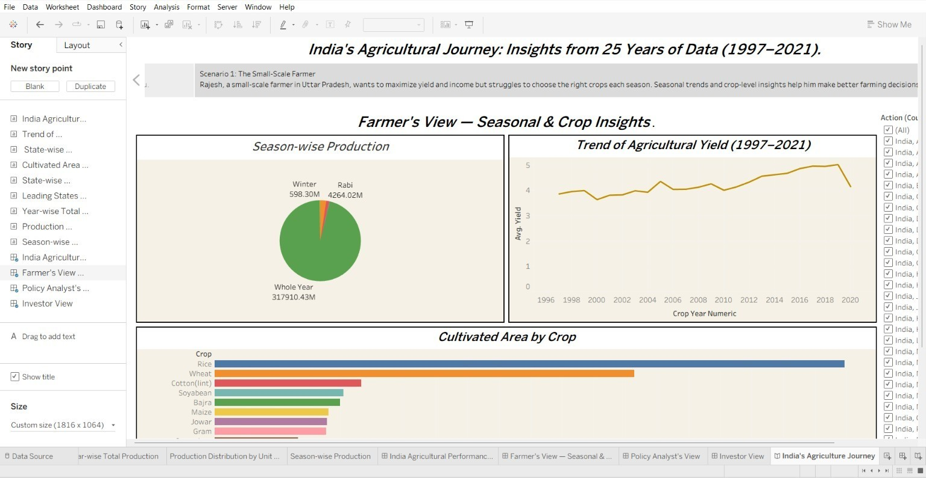
Story Point 2 — Scenario 1: The Small-Scale Farmer

Story Point 3 — Scenario 2: The Government Policy Analyst
Ananya, at the Ministry of Agriculture, needs to design policies that improve productivity nationwide using the Policy Analyst's View.

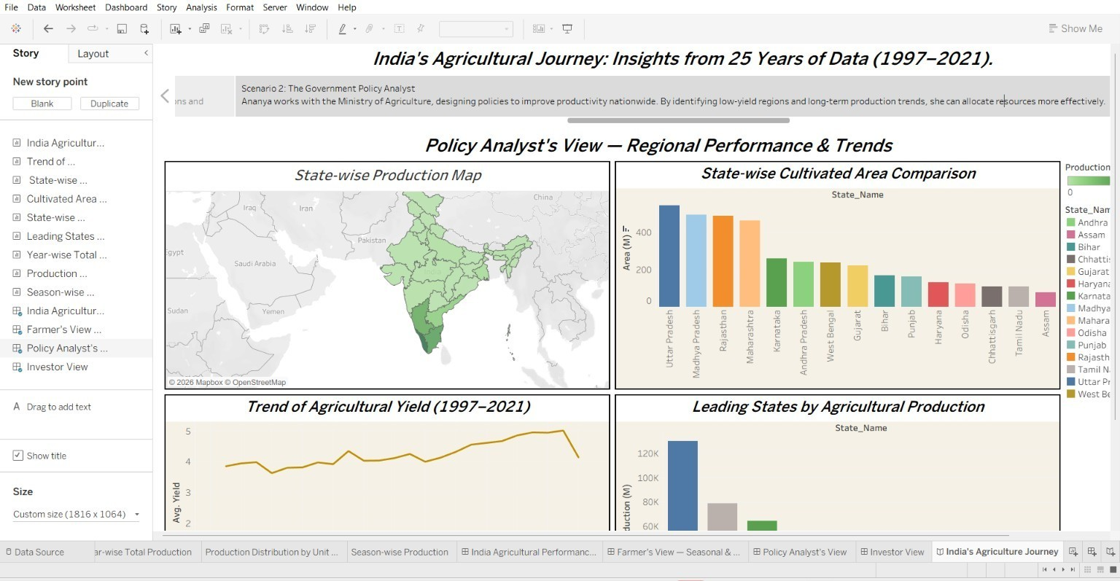
Story Point 3 — Scenario 2: The Government Policy Analyst

Story Point 4 — Scenario 3: The Agribusiness Investor
Vikram is looking to invest in high-growth agricultural sectors using the Investor's View.

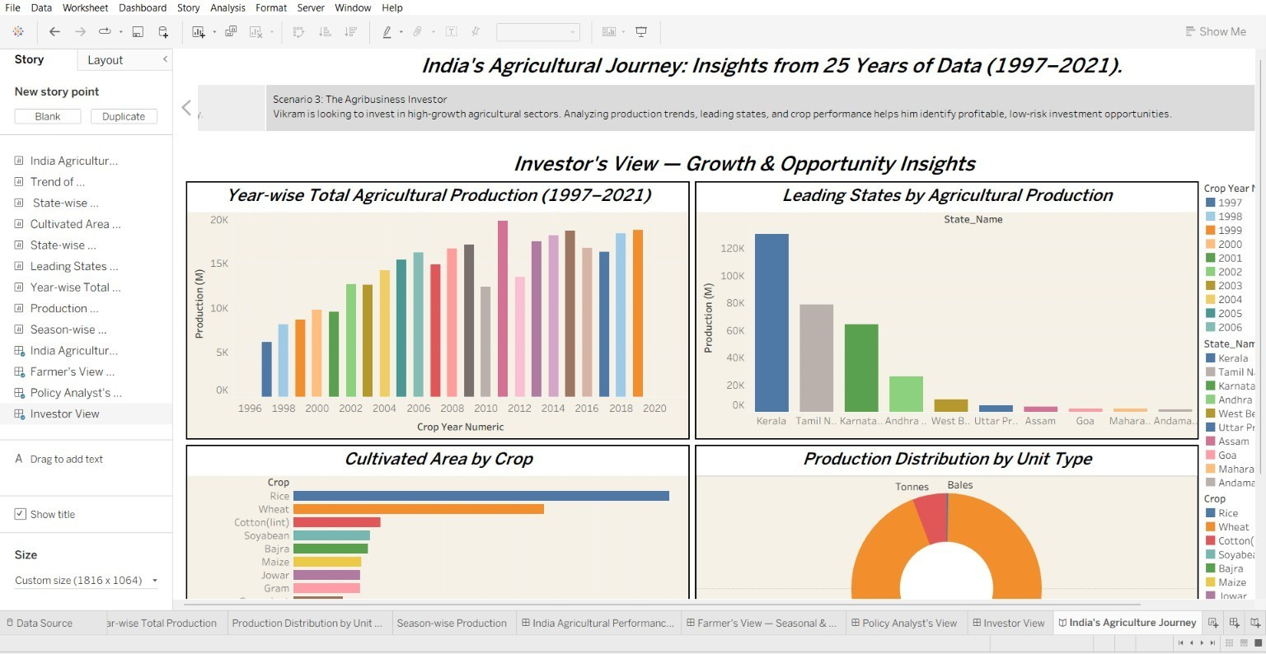
Story Point 4 — Scenario 3: The Agribusiness Investor

Story Point 5 — From Data to Decisions
Closes the Story: whether farmer, policymaker, or investor, 25 years of agricultural data turns complexity into clarity and insight into action.

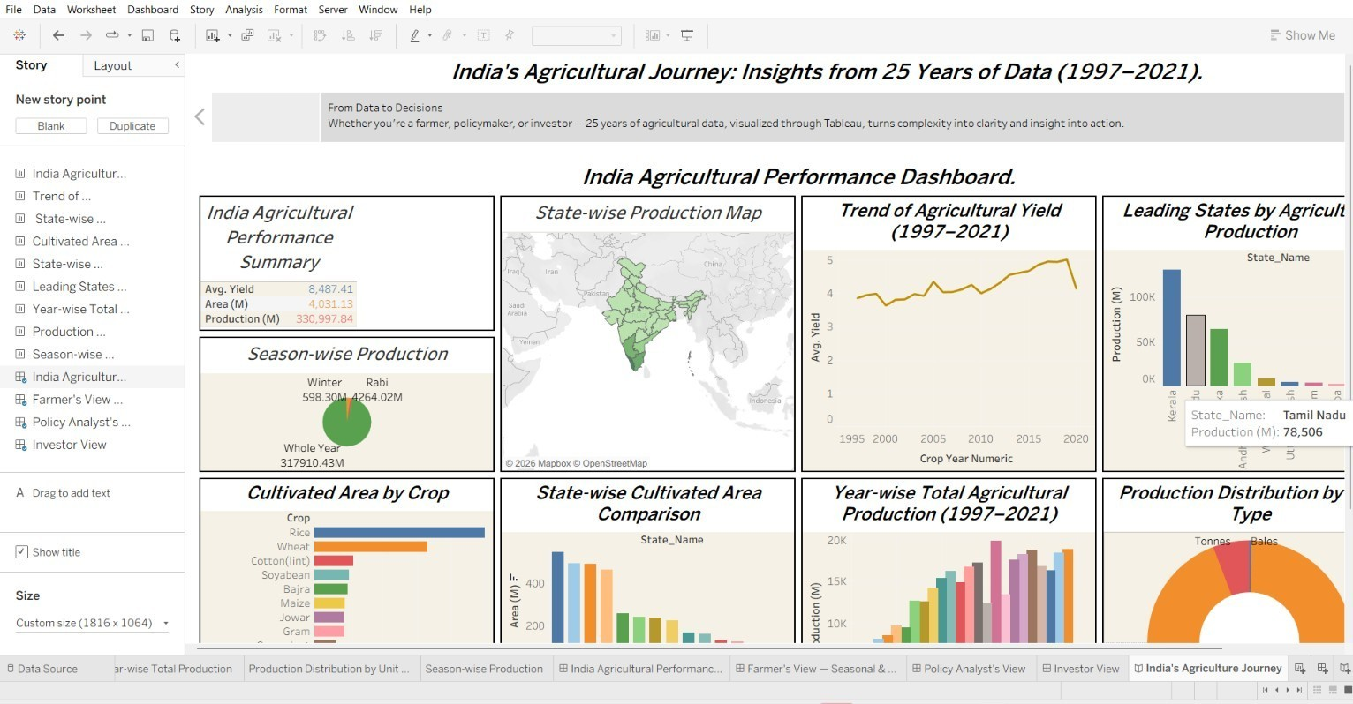
Story Point 5 — From Data to Decisions

